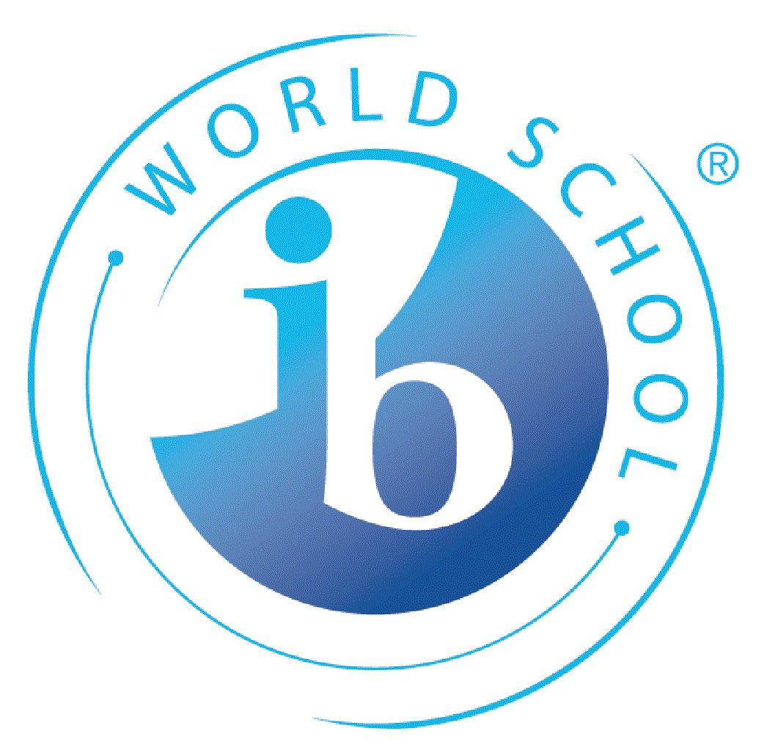
Application for International Baccalaureate (IB) at KKG

Name:  Klikk eller trykk her for å skrive inn tekst. | School year:  Klikk eller trykk her for å skrive inn tekst.
Complete address:  Klikk eller trykk her for å skrive inn tekst. | Date of birth:  Klikk eller trykk for å skrive inn en dato.
Telephone:  Klikk eller trykk her for å skrive inn tekst. | Norwegian national security number:  Klikk eller trykk her for å skrive inn tekst.
E-mail address:  Klikk eller trykk her for å skrive inn tekst. | Nationality:  Klikk eller trykk her for å skrive inn tekst.
Reasons for choosing IB:  Klikk eller trykk her for å skrive inn tekst. | Previous schools:  Klikk eller trykk her for å skrive inn tekst.

Please attach a copy of a record of your former schooling; “Vitnemål fra ungdomsskolen”, “Karakterutskrift fra videregående skole” or last school report from any other school and send it to vibeke.lauritsen@kkg.vgs.no together with this application form.

Remember also to fill in an electronic application at www.vigo.no and send it to “Inntakskontoret”.

Deadline for both applications: 1. March

Choice of subjects:

All IB-students are required to take six subjects; one from each of the groups 1-5 below and as the 6.th subject you chose another subject from groups 2-4.

Three subjects must be taken at Higher Lever (HL) and three at Standard Level (SL).

For further information: KKGs IB home pages https://kkg.vgs.no/utdanningstilbud/ib-diploma-programme/ or IBO www.ibo.org

This is how you do it:
- Choose 6 subjects, one from each group and one subject in addition in group 2-4
- You may choose two Group 1 languages instead of one subject in Group 1 and 2.
- ESS can be both group 3 and group 4.

Note: Due to collisions on the timetable it is not possible to choose
- both Physics and Languages B (Spanish, German, French HL and Chinese ab initio)
- both Biology and ESS.
- both HL Maths and Biology, Chemistry
- both History and Economics and Psychology

 |  |  | Higher Level(HL) | Standard Level(SL)
Group 1 | Language A Lang. and Lit. | Norwegian A Language and Literature | ☐ | ☐
 |  | English A Language and Literature | ☐ | ☐
Group 2 | Language acquisition | Norwegian B (HL only) | ☐ | ☐
 |  | English B (HL only) | ☐ | ☐
 |  | French B | ☐ | ☐
 |  | German B | ☐ | ☐
 |  | Spanish B | ☐ | ☐
 |  | Chinese ab initio (SL only) | ☐ | ☐
Group 3 | Individuals and societies | Economics | ☐ | ☐
 |  | History | ☐ | ☐
 |  | Psychology | ☐ | ☐
 |  | Envir. syst. & soc., ESS (SL only) | ☐ | ☐
 |  | Global politics (SL only) | ☐ | ☐
 |  | ITGS – via Pamoja | ☐ | ☐
Group 4 | Sciences | Biology | ☐ | ☐
 |  | Physics | ☐ | ☐
 |  | Chemistry | ☐ | ☐
 |  | Envir. syst. & soc., ESS (SL only) | ☐ | ☐
Group 5 | Mathematics | Mathematics: application and interpretation (SL only) | ☐ | ☐
 |  | Mathematics: analysis and approaches | ☐ | ☐

Contact the IB Coordinator if you have question about the subjects vibeke.lauritsen@kkg.vgs.no

