Admissions Policy for the Diploma Programme at
Kristiansand katedralskole Gimle (KKG)

Kristiansand katedralskole Gimle (KKG) is a state school that is primarily an offer for students living in Agder. According to Norwegian law, all students between the ages of 16 to 24 have the right to admission to an upper secondary programme. The IB Diploma Programme is a challenging, broad and balanced two-year programme of international education for students aged 16 to 19. The programme is designed to equip students with the basic academic skills needed for university study, further education and their chosen profession, as well as developing the values and life-skills needed to live a fulfilled and purposeful life.

Requirements

IB at KKG requires a student to study languages, social sciences, natural sciences and mathematics over two years. It is based on the first year of Norwegian videregående skole, or similar academic preparation. The IB Diploma course is taught in English and is designed to cater for internationally mobile student applicants and Norwegian students interested in a secondary school education preparing them for universities in Norway and abroad.

Necessary qualifications:
- Completed Vg1 studiespesialisering or Vg1 studieforberedende
- Grade 4 or better in Vg1 English – or a similar English course
- Grade 4 in Vg1 1T Mathematics – or similar level of Mathematics
- A fulfilled IB middle years program (MYP5) – with 5,8 in average grade
  - 3 in all subjects, but 5 in Mathematics
  - A minimum of Norwegian phase 4
  - Approved soft skills
- Completed 10th grade in the Norwegian school system if students are mature and have completed Matematikk 1T and Vg1 English
- Equivalent qualifications to any of the above, including a minimum of 10 years of schooling

- Norwegian skills: All IB Diploma Programme students at KKG are to be qualified to study both at universities in Norway and abroad, so students must have enough Norwegian skills to be able to pass Norwegian B HL (with a grade of 3). If necessary, they need to attend a Norwegian course outside school at their own expence.

Criteria for admission

We look for candidates:

- who are motivated and determined
- whose academic performance is average to excellent
- whose conduct is good overall, and who are respectful to others
- who are committed to the school’s vision, mission and philosophy
- who are internationally-minded
- who would benefit from the IBDP curriculum
- who want to take a full IB Diploma Programme
- whose qualities would enrich the IB community and be a positive contribution to it
- who have a registered address in Agder county by the application deadline which is March 1.

Applicants who are in the process of moving to the region before July 1. are eligible to apply for a place. They will, however, not secure a place until they provide documentation to prove that they have moved to an address in Agder together with or in order to join their parents/family before the start of the school year. Students must have registered address in Agder throughout the time they attend KKG.

Students should usually follow the same age cohort as Vg2 and Vg3 students in Norwegian public schools. Students at Upper Secondary courses typically begin at Vg2 in their 17th year.

The Admissions Committee has the right to accept or refuse any applicant based on their assessment of the applicant’s suitability.

Admission rules for the IB for Agder county from 2020 (in Norwegian only)

§ 9 Inntak til International Baccalaureate Diploma Programme (IB)
Søkere til International Baccalaureate (IB) skal sende inn elektronisk søknad via www.vigo.no og fylle ut eget tilleggsskjema som sendes direkte til aktuell skole.
Søknadsfristen er 1. mars.
Den aktuelle skolen fatter vedtak om inntak til IB, basert på en individuell vurdering.
For å kunne vurderes for inntak til IB må søker ha bestått Vg1 studiespesialisering, Vg1 studiespesialisering med forberedende IB eller tilsvarende utdanning i utlandet. Søkere som har gått 10. klasse på en IB-skole i Norge eller utlandet kan også søke inntak til Vg2 International Baccalaureate.
Vilkår for inntak til Vg3 IB er fullført og bestått Vg2 IB.
Admissions Committee and decision-making process

All students that have completed Vg1 studiespesialisering or Vg1 studieforberedende in the national school system in Agder may apply to the IB Diploma Programme (DP). However, we recommend that students attend Pre IB Vg1 (Studiespesialisering med focus på internasjonalisering) at KKG to be prepared for the DP.

The Admissions Committee is comprised of the IB coordinator, the school’s education counsellor for the IB and Pre IB and subject teachers (especially home room teachers). There are several meetings about the students during Vg1 (called klasselærerråd og trippelmøter) where students are evaluated, and the students are recommended or not recommended to apply for the IB.

The final decision on all applications rests with the IBDP coordinator.

Admissions meeting

The IB Coordinator meets with the applicants before the deadline for application which is March 1. The meeting will focus on the candidate’s motivation and choice of subjects. Applicants not from KKG, bring their grades (including their absence) and we also receive information about the students from their former school.

If the student has not attended schools in Norway or in the IB system, we decide whether they do Pre IB before attending the IB. If the educational background of the student is hard to determine, the student might have to take an entrance test in Mathematics and English. An interview will be required to discuss the application. We prefer to arrange a visit to our school, at least before school starts in August.

To stay in the IB Programme
Students will need to meet all requirements listed in the Master time schedule before they can start 3IB, including CAS, first draft of the EE and having completed any IA processes listed in the schedule.

Students will have the first 6 weeks of the 2IB year to “switch” IB courses. Students’ grades will be reviewed at Christmas and at the end of 2IB. Students with predicted grades lower than a total of 24 marks (no grade 1s, and not more than two grade 2s awarded in the subjects), will be advised to start Vg2 or Vg3 studiespesialiserende instead of moving to 3IB.

Undocumented absence should not exceed 10 % in any of the subjects.

- The IBO expects students to participate in the IB curriculum as structured and required by the school, to comply with all subject-specific regulations and internal school deadlines, and to complete the diploma over a period of two years.

Students are registered for the exam by November, but if a student has not delivered the Extended essay or handed in the required internal assessments assigned in a particular subject or CAS due on the due date, he/she will not be registered for the exams.

How to apply:
Students apply electronically through www.vigo.no by March 1.

All applicants must also fill out an IB application form which is to be sent directly to the school. The form is to be found at KKG`s website. If you wish to apply, please print out the application form and send it to the school before March 1.

Alternatively, if you are applying from abroad and do not have a Norwegian identity number and/or do not have records of previous schooling from Norway, you should send in an application in paper format or my e-mail to "Inntakskontoret" as well as applying directly to the school by sending the IB application form.
Your application will be reviewed by the school’s Admissions Committee in June.

More information about the IB can be found on the school website and on the IBO website: http://www.ibo.org/

If you have any further questions, please contact Vibeke Lauritsen, IB Coordinator at Kristiansand katedralskole Gimle. E-mail: Vibeke.Lauritsen@kkg.vgs.no

Application form (in addition to www.vigo.no)

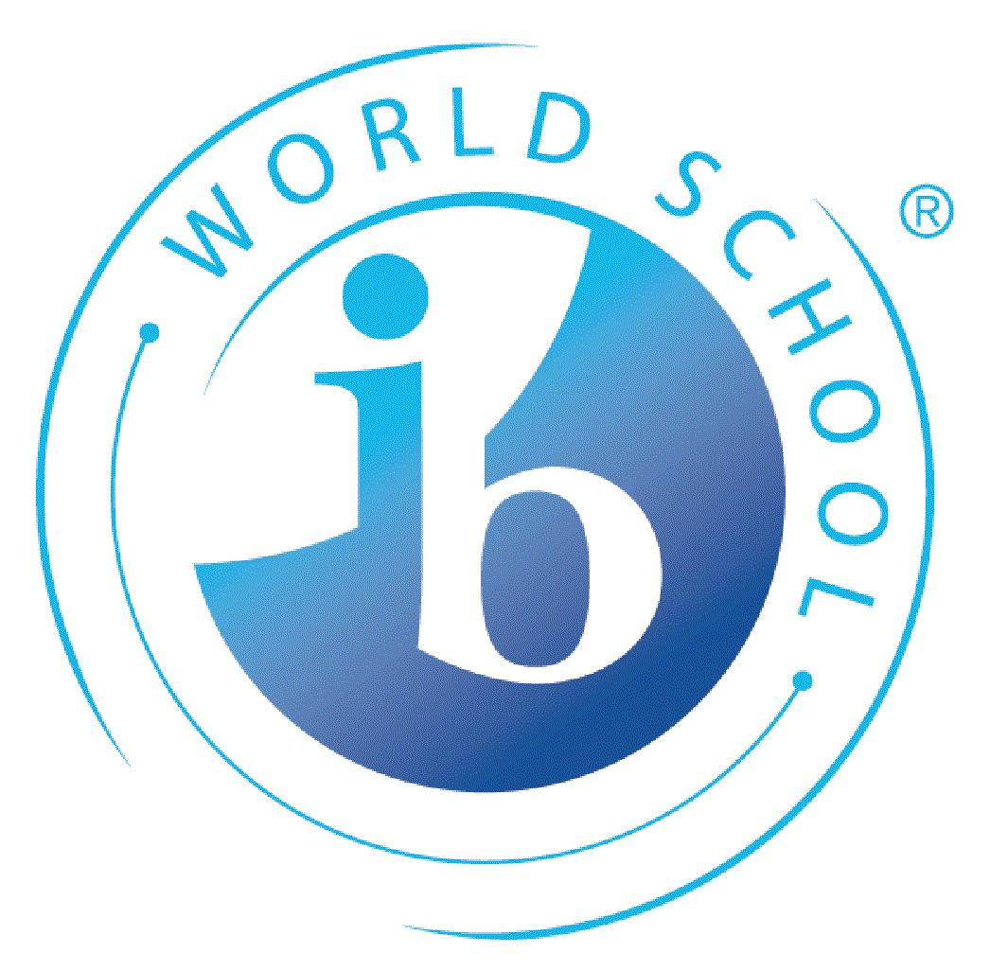
Application for International Baccalaureate (IB) at KKG

Name: | School year:
Complete address: | Date of birth:
Telephone: | Norwegian national security number:
E-mail address: | Nationality:
Reasons for choosing IB: | Previous schools:

Please attach a copy of a record of your former schooling; “Vitnemål fra ungdomsskolen”, “Karakterutskrift fra videregående skole” or last school report from any other school and send it to kontakt@kkg.vgs.no together with this application form.

Remember also to fill in an electronic application www.vigo.no

Deadline for both applications: March 1.

Choice of subjects:

All IB-students are required to take six subjects; one from each of the groups 1-5 below and, as the 6.th subject you chose another subject from groups 2-4.

Three subjects must be taken at Higher Lever (HL) and three at Standard Level (SL).

For further information: KKGs IB home pages https://kkg.vgs.no/utdanningstilbud/ib-diploma-programme/ or IBO www.ibo.org

 |  |  | Higher Level (HL) | Standard Level (SL)
Group 1 | Language A Lang. and Lit.
 |  | Norwegian A Language and Literature
 |  | English A Language and Literature
Group 2 | Language acquisition
 |  | Norwegian B (HL only)
 |  | English B (HL only)
 |  | French B
 |  | German B
 |  | Spanish B
 |  | Chinese ab initio (SL only)
Group 3 | Individuals and societies
 |  | Economics
 |  | History
 |  | Psychology
 |  | Envir. syst. & soc., ESS (SL only)
 |  | Global politics (SL only)
 |  | ITGS – (online, Pamoja)
Group 4 | Sciences
 |  | Biology
 |  | Physics
 |  | Chemistry
 |  | Envir. syst. & soc., ESS (SL only)
Group 5 | Mathematics
 |  | Mathematics: application and interpretation (SL only)
 |  | Mathematics: analysis and approaches

You choose 6 subjects, one from each group and one subject in addition in group 2-4

You might choose two Group 1 languages instead of one subject in Group 1 and 2.
ESS can be both group 3 and group 4.

Choosing both Physics and Languages B (Spanish, German, French HL and Chinese ab initio) or Biology and ESS is not possible because of the timetable. The same goes for Chemistry and History and Economics and Psychology

Contact the IB Coordinator if you have question about the subjects vibeke.lauritsen@kkg.vgs.no

Kristiansand 1.3.2020.

Knut G. Aasen Vibeke Lauritsen
Head of School IB Coordinator

